Vehicle Accident Detection System
Using Arduino

PROJECT REPORT

Submitted by

B. ASWIN

ABSTRACT

In our Modern world, Transportation has great importance in our daily life and it’s development has made many of our chores much easy.An accident prevention system is being introduced with accident identification for vehicles that give a higher probability to reduce the accidents taking place every day on roads and at the same time if accident occurs, the system is locate its place and automatically inform those people who is be able to take immediate actions. Here, an Arduino based system has been developed by using Global Positioning System (GPS) and Global System for Mobile Communication (GSM) technology. An accelerometer also used that is measure the velocity and the amount of the vehicle’s tilting when it will struck over something. When the velocity of the car to be more than the defined maximum velocity for the road or it tilts, a warning is be given automatically. Also, whenever an accident will take place, the GPS will locate the geographical coordinates for that particular place, and using the GSM it will send an SMS. The system is of low-cost and is user friendly.

TABLE OF CONTENTS

CHAPTER NO. | TITLE | PAGE NO.
 | ABSTRACT | i
 | ACKNOWLEDGEMENT | ii
 | LIST OF FIGURES | v
1. | INTRODUCTION | 1
2. | LITERATURE SURVEY | 4
3. | SYSTEM REQUIREMENTS | 8
4. | SYSTEM ANALYSIS | 9
5. | SYSTEM DESIGN | 10
6. | SYSTEM IMPLEMENTATION | 14
7. | SYSTEM TESTING | 17
8. | CONCLUSION AND FUTURE ENHANCEMENT | 19
 | APPENDIX
 | CODING
 | SCREENSHOTS
 | REFERENCES

LIST OF FIGURES

FIGURE NO. | TITLE | PAGE NO.
5.1 | Encoder Architecture of the proposed system | 10
5.2 | Decoder Architecture of the proposed system | 11
5.3 | Flow Diagram of the proposed system | 13

CHAPTER 1
INTRODUCTION
In today’s world there is a severe increase in the use of vehicles. Such heavy automobile usage has increased traffic and thus resulting in a rise in road accidents. This takes a toll on the property as well as causes human life loss because of unavailability of immediate preventive and safety facilities. Complete accident prevention is unavoidable but at least repercussions can be reduced.
The cost of road accidents is borne not only by the victims and their family, but by the economy as a whole in terms of untimely deaths, injuries, disabilities and loss of potential income. During the year 2020, the total recorded 3,66,138 road accidents caused loss of 1,31,714 persons lives and injured 3,48,279 persons. Unfortunately, the worst affected age group in Road accidents is 18-45 years, which accounts for about 70% of total accidental deaths
According to WHO, Every year the lives of approximately 1.3 million people are cut short as a result of a road traffic crash. Between 20 and 50 million more people suffer non-fatal injuries, with many incurring a disability as a result of their injury.
Road traffic injuries cause considerable economic losses to individuals, their families, and to nations as a whole. These losses arise from the cost of treatment as well as lost productivity for those killed or disabled by their injuries, and for family members who need to take time off work or school to care for the injured. Road traffic crashes cost most countries 3% of their gross domestic product.
This road accident takes a toll on the property as well as causes human life loss because of unavailability of immediate preventive and safety facilities. Complete accident prevention is unavoidable but at least repercussions can be reduced. This embedded system can prevent the accident to occur and proper preventive measures are taken in this system. The ambulance service and the police station can easily find the location as the location along with the google map link was sent to their smart devices with mobile network accessibility.
When there is an unexpected acceleration in the accelerometer and a severe change detected by the vibration sensor, the system will consider it an accident. Henceforth, it will alert the GSM and GPS modules, which will further detect the location and send a message indicating the accident with the location where it has occurred. This research aids in providing a feasible solution to the poor emergency it enables. The existing system mostly focuses on the safety of the passenger but not on the immediate help after an accident. The system implemented by us aims at automatically detecting an accident and alerting the nearest hospital or medical services about the exact location of the accident. Within seconds of an accident, this system sends basic information to the medical rescue team. This device can detect accidents and send an alert message to rescue teams in significantly less time, which will help in saving the lives of people.

1.1 PROJECT OVERVIEW
In order to reduce the risk of delay treatment causes to death, This device can detect accidents and send an alert message to rescue teams in significantly less time, which will help in saving the lives of people.
1.2 OBJECTIVE OF THE PROJECT
- The objective is to overcome accidents by monitoring any change in the speed ofthe vehicle whereas the accelerometer can detect the fall.
- The Arduino is the major control unit to detect or alert when an accident occurs. It collects the data from the accelerometer, GPS, GSM modules and reflects theoutput.
- This will reach the rescue service in time and save lives.

1.3 ADVANTAGES OF THE PROJECT
- They are cost-effective in implementation.
- They have a high tendency to assure safety.
- The victim's life can be saved quickly involved in the accident.
- It has low power consumption.
- It has better accuracy.
- There is efficient time consumption.
- It reduces the chance of human error.

1.4 DISADVANTAGES OF THE PROJECT
- There is a possibility of false reporting of an accident at low speed.
- Damage to the sensor cannot be detected.
- In some places where there is no provision of GSM networks, it is difficult for communication.
- The application does not have an offline mode.
- The biggest problem is the blockage of signal transmission by mountains, high buildings, and tunnels.

CHAPTER 2
LITERATURE REVIEW
2.1Analysis of Driving Characteristics and Crash Detection
Murat ERAT, ÖmerŞahin KARAMAN, Yunus KARAMAVUŞ proposed the method aims at making a Crash Detection using IoT technologies.This project uses Arduino Nano, GPS, GSM Module, Gyro Sensor, G-Sensor to detect crash detection and inform to a person.
Advantage
- It detect crash correctly
Disadvantage
- It is Expensive
2.2 A Novel Algorithm for Crash Detection Under General Road Scenes Using Crash Probabilities and an Interactive Multiple Model Particle Filter
Taewung Kim and Hyun-Yong Jeong proposed the method aims at making a crash detection using IoT technologies and Artificial Intelligence. This project use the artificial intelligence to detect crash earlier and inform to the person.
Advantage
- It can prevent earily.
Disadvantage
- It is compilicated.
2.3 Sensor Fusion System for Pre-crash Safety System
S.Tokoro, K.Moriizumi, T.Kawasaki, T.Nagao, K.Abe and K.Fujita proposed the method aims at making a Pre- Crash Safety System using Artificial Intelligence. This project uses Obstacle detection sensor and vision based sensor was compare and convert it into image view and detect the crash early and give waring to the driver.
Advantage
- An accurate Crash detection can be achieved..
Disadvantage
- It is Expensive.
2.4 Using Hidden Markov Models in Vehicular Crash Detection
Gautam B. Singh proposed the method aims at making a Vehicular Crash Detection using IoT technologies. This project uses crash pulse Sensor in left and right side to detect the vehicle crash.
Advantage
- It is use the mathematic to detect the crash..
Disadvantage
- It is Complicated some times occur errors.
2.5 Pedestrian and Bicyclist Crash Scenarios in the U.S
RiniSherony*, Chong Zhang proposed the method aims at making a Pedestrian and bicyclist crash Scenarios Using IoT technologies. This project use motion sensor and light sensor to detect the a person or small vehicle to prevent the accident.
Advantage
- It is usefull for small vehicle for night time..
Disadvantage
- This implement not available in India.
2.6 Preliminary Potential Crash Prevention Estimates for an Intersection Advanced Driver Assistance System in Straight Crossing Path Crashes
John M. Scanlon, RiniSherony, and Hampton C. Gabler proposed the method aims at making a I-ADAS using Artificial Intelligence. This project use I-ADAS installed vehicle in USA and get data from internet and implement the guess to prevent the accident in the straight crossing path.
Advantage
- It is automatically apply the break.
.
Disadvantage
- This device not able to used in all vehicle.
2.7 Performance Analysis of a Vehicle Crash Control System using Image
Processing
Sriram Murali and Ramachandran Shankar proposed the method aims at making a Vehicle crash control system using image processing using Artificial Intelligence and IoT technologies. This project use eye tracking sensor to monitor the eye blinking if we fall asleep the sensor was give sound alert.
Advantage
- It is Usefull for not to fall asleep.
Disadvantage
- Some times it give false alert.
2.8 S-CarCrash: Real-time Crash Detection Analysis and Emergency Alert using Smartphone
Harit Sharma, Ravi Kanth Reddy, Archana Karthik proposed the method aims at making a crash detection and emergency alert using IoT technologies. This project use ACN and ADAS sensor to detect the impact and send emergency alert using their smartphone.
Advantage
- Easy to implement.
Disadvantage
- If smartphone was broke emergency alert was not able to send to rescue team.
2.9 Novel Vehicle Crash Risk Detection based on Vehicular Sensory System
Qingdon Zeng, Liqunpengproposed the method aims at making a crash detection and using IoT technologies. This project usewireless communication device to contact each vehicle, If the vehicle come to crash like situation the sensor was help pull the break and prevent from the accident.

Advantage
- Easy to implement.
Disadvantage
- It is Expensive.
2.10 Trends in Crash Detection and Occupant Restraint Technology
Ching-Yao Chan proposed the method aims at making a crash detection. This project useautomotive restraint, crash mitigation, occupant protection,vehicular safety systems, Airbags. If Crash happen the airbags and seat belt was prevent the passenger from heavy injuries.
Advantage
- It react fraction of second to prevent the passenger from major injuries..
Disadvantage
- Some times it fails to open.

CHAPTER 3
SYSTEM REQUIREMENTS

3.1 HARDARE REQUIREMENTS
- Arduino Nano or UNO
- LCD I2C
- NEO6M GPS Module
- SIM800L GSM Module
- micro sim card
- Piezoelectric Buzzer
- push button with 1K Resistor.

3.2 SOFTWARE REQUIREMENTS
- Arduino IDE.

CHAPTER 4
SYSTEM ANALYSIS

4.1 EXISTING SYSTEM
There are many solutions proposed for the concerned problem and each one have some advantage over others.Among the other GSM and GPS solutions, some proposed the solution of finding the accidentcondition using only accelerometer sensor which may be a problem as it may lead to false alarm for some of the cases. Our system usesmore than one sensor to increase the accuracy of the system and also we have provision to avoid the intimation in case of false alarm.

4.1.1 DISADVANTAGES OF EXISTING SYSTEMS
- False Detection
- Expensive

  - PROPOSED SYSTEM
In the proposed system, we have avoided the false alarm situation caused for some conditions, increased theaccuracy of accident detection using more than one sensor, cut the project cost by using the already existinginfrastructure available in the victim’s mobile phone. To avoid the false alarm we have one manual switch in thevehicle itself which must be pressed within 10 second of false accident detection and hence avoiding any falseintimation. Within of limited time of buzzer signal the GPS module collects the coordinatesfrom Google Module. These co-ordinates nearby hospitals are alerted for emergency rescue call topassenger. The hospital approves the accident by verifying the accident at specified locationand confirms the accident. The saved personal members of family are informed regarding the accident throughGSM module.
    - ADVANTAGES OF THE PROPOSED SYSTEM
- Low cost and Efficient
- High tendency to assure safety.
- The victim's life can be saved quickly involved in the accident.
- It has low power consumption.
CHAPTER 5
SYSTEM DESIGN

5.1 ARCHITECTURE OF THE PROPOSED SYSTEM

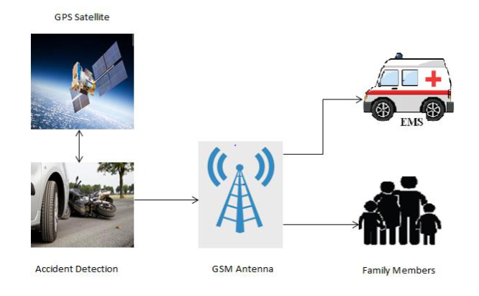
Figure 5.1
This system architecture is helpful to minimize the time needed for the ambulance to reach the accident area and also send user detail to that ambulance it is helpful for finding the address and also the blood group of that person. This information can send to corresponding person’s family member automatically with help of this system. The accident is find out with the help of accelerometer at the same time GPS get the exact location of the accident place and that data is send to ambulance drive.
5.1.1 Crash Detection:
The vehicle was got accident the ADXL 335 accelerometer sensor get moment immediately the sensor was give the warning sound if the crash was not much just press the reset button. If the crash was real the tri-axial threshold value will be changed. With the help of gps and gsm, a alert call and gps location was send to your loved one’s and immediately take action.
5.2 ALGORITHM FOR THE PROPOSED SYSTEM
5.2.1 Algorithm for crash detection
The method of detecting impact through absolute values is as follows.
|x2| – |x1| > x axis threshold
|y2| – |y1| > y axis threshold
|z2| – |z1| > z axis threshold
The G-sensor value can reflect the period by sampling that is the changeable value. In this paper, the sampling period is 10ms for testing. x1, y1, z1 are the previous values, and x2, y2, z2 are the changed values after 10ms. When the previous value is subtracted from the changed value as in Equation 2, if the corresponding value is higher than each predetermined threshold value, it can be determined as the crash event.

BLOCK DIAGRAM
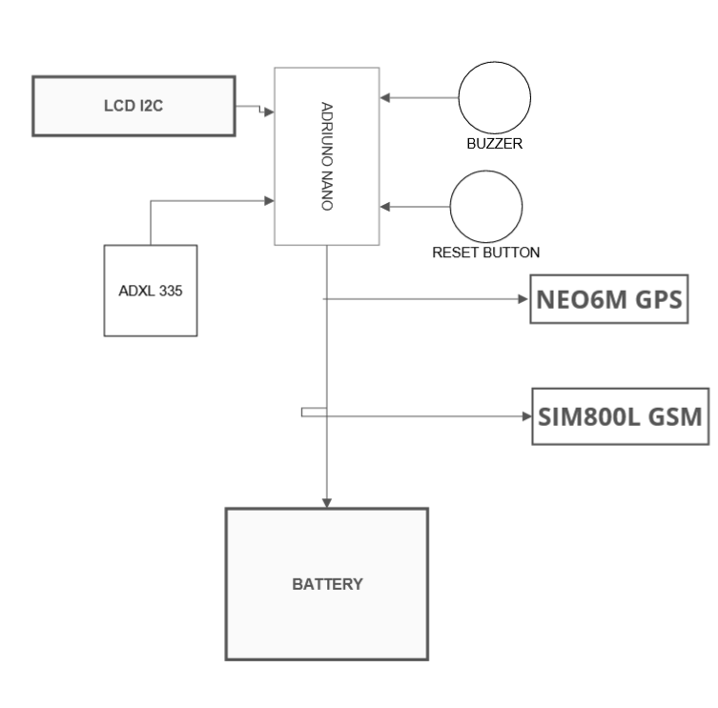

FLOW DIAGRAM
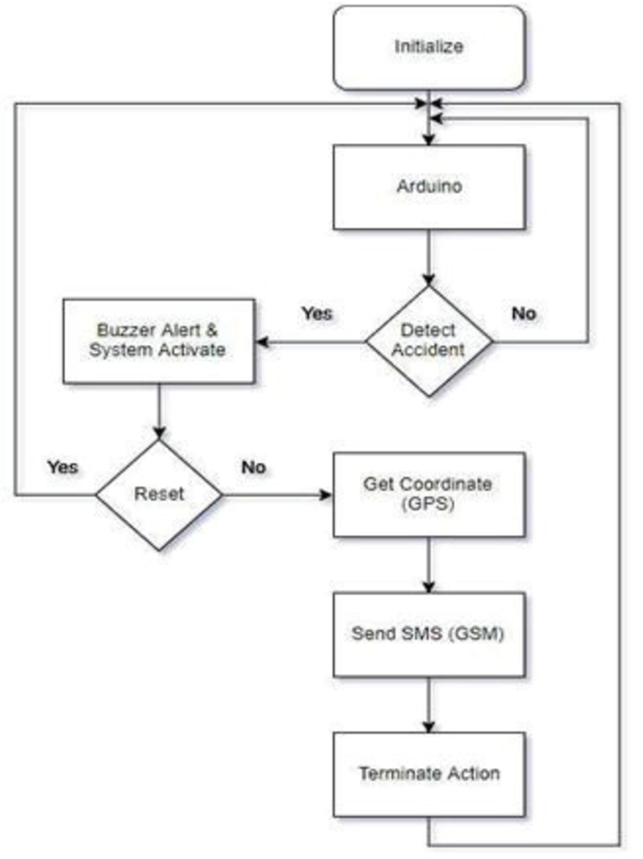
Figure 5.3
CHAPTER 6
SYSTEM IMPLEMETATION

6.1.1 CRASH DETECTION MODULE
When the power is given to the Arduino Nano Device it also gives power to the ADXL 335 Accelerometer via vcc and gnd pin which is connected to the vcc and gnd pin of the Arduino.
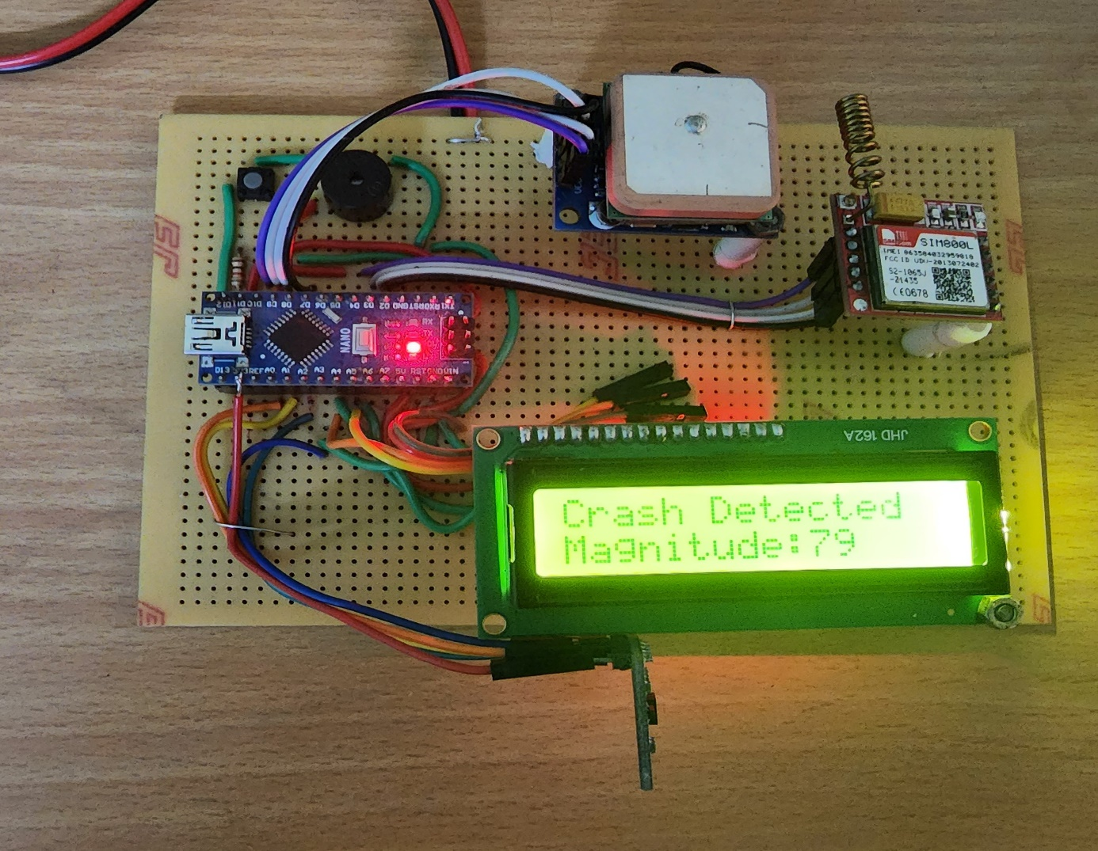
When the ADXL 335 Accelerometer was detect the crash and change the set value and it detect it is accident and show in the I2C LCD Display which is the SCL and SCA was Connected via A3 and A4 of the Arduino Nano.

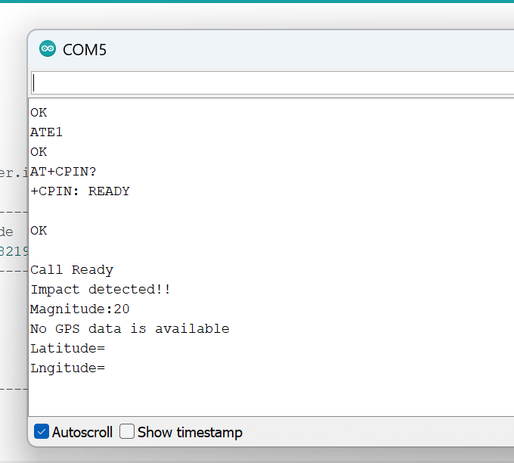
These data are sent to Microcontroller continuously via Trig and Echo pin that is connected to the D12 and GND pin of the Arduino. If the accident detect that we assigned then the signal is sent to the buzzer via D12 and GND pin of the Arduino the sound alert is given viabuzzer.
If the accident alert was false we can off the alert with the help of reset button which is connected to the D11 and GND pin of the Arduino.
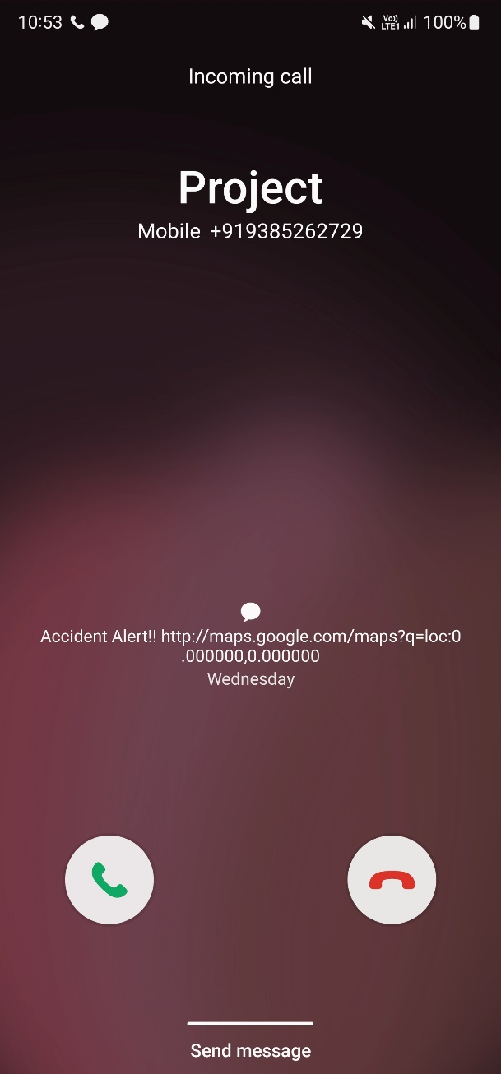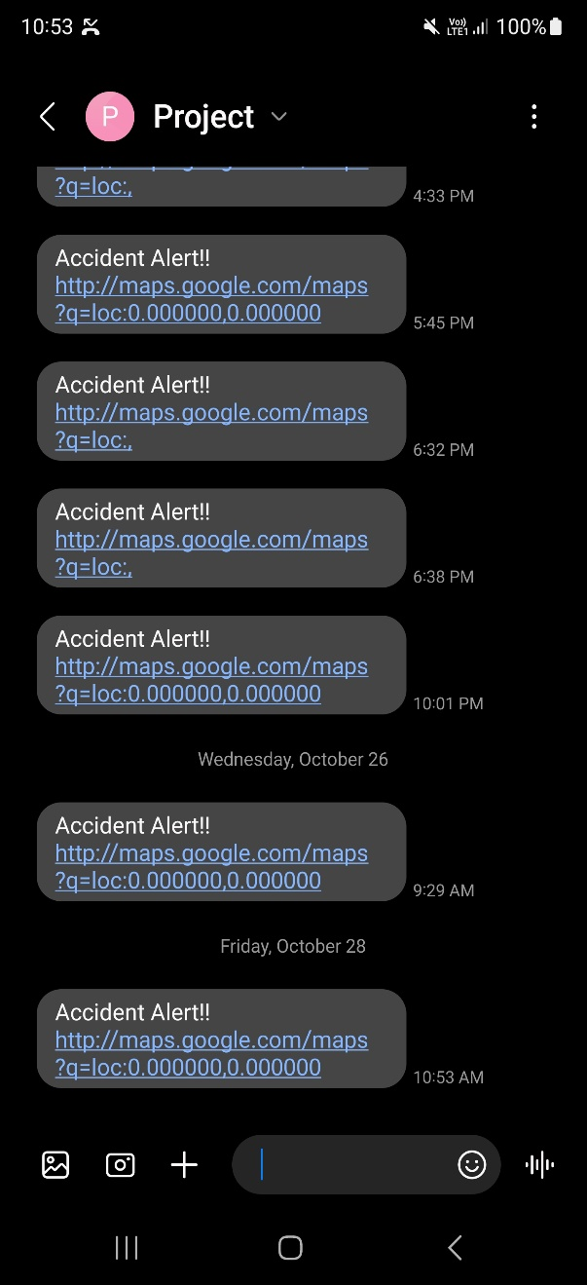
When the accident was happen with the help of SIM800 Module which is connected to D2 and D3 of the Arduino was give the accident phone call alert and with the help of NEO6-M GPS was connected to D8 and D2 of the Arduino was send the Location.

CHAPTER 7
SYSTEM TESTING
The purpose of testing is to discover errors. Testing is the process of trying to discover every conceivable fault or weakness in a work product. It provides a way to check the functionality of components, sub-assemblies, assemblies and or a finished product. It is the process of exercising software with the intent of ensuring that the software system meets its requirements and user expectations and does not fail in an unacceptable manner. There are various types of test. Each test type addresses a specific testing requirement.
7.1 TYPES OF TESTING
In this project six testing based on the needs that this application going to satisfy. The testing used in this project are:
- Unit Testing
- Performance Testing
- End-to-End Testing
- Functional Testing
- Acceptance Testing
- Smoke Testing
- Integration Testing
7.1.1 Unit Testing
Unit Testing is a type of software testing where individual units or components of a software are tested. The purpose is to validate that each unit of the software code performs as expected. Unit Testing is done during the development (coding phase) of an application by the developers. Unit Tests isolate a section of code.
7.1.2 Performance Testing
Performance Testing is a software testing process used for testing the speed, response time, stability, reliability, scalability, and resource usage of a software application under a particular workload. The main purpose of performance testing is to identify and eliminate the performance bottlenecks in the software application.

7.1.3 End-To-End Testing
End To End Testing is a software testing method that validates entire software from starting to the end along with its integration with external interfaces. The purpose of end-to-end testing is testing whole software for dependencies, data integrity and communication with other systems, interfaces, and databases to exercise complete production like scenario.
7.1.4 Functional Testing
Functional Testing is a type of software testing that validates the software system against the functional requirements/specifications. The purpose of Functional tests is to test each function of the software application, by providing appropriate input, verifying the output against the Functional requirements.
7.1.5 Acceptance Testing
It is a formal testing according to user needs, requirements and business processes conducted to determine whether a system satisfies the acceptance criteria or not and to enable the users, customers, or other authorized entities to determine whether to accept the system or not.
7.1.6 Smoke Testing
Smoke Testing is a software testing process that determines whether the deployed software build is stable or not. Smoke testing is a confirmation for QA team to proceed with further software testing. It consists of a minimal set of tests run on each build to test software functionalities. Smoke testing is also known as “Build Verification Testing” or “Confidence Testing.
7.17 Integration Testing
Integration Testing is defined as a type of testing where software modules are integrated logically and tested as a group. A typical software project consists of multiple software modules, coded by different programmers. The purpose of this level of testing is to expose defects in the interaction between these software modules when they are integrated.

CHAPTER 8
CONCLUSION AND FUTURE ENHANCEMENT
The project of Vehicle Accident Detection System Using Arduino has been build and tested successfully. It has been developed by integrated features of all the hardware components used. The ADXL 335 Accelerometer was get change the set value and detect it accident and give sound alert via Buzzer and if the alert was false off the system using via reset button, or it’s real with help of sim800l and NEO-6M send the call alert and send the location to the concerned person.

APPENDIX
APPENDIX A:
#include <LiquidCrystal_I2C.h>
#include <AltSoftSerial.h>
#include <TinyGPS++.h>
#include <SoftwareSerial.h>
#include <Wire.h>
#include <math.h>

// LCD
LiquidCrystal_I2C lcd(0x27, 16, 2);

// Emergency phone number with country code
const String EMERGENCY_PHONE = "+918428482197";

// Pins
#define rxPin 2
#define txPin 3
#define xPin A1
#define yPin A2
#define zPin A3
const int BUZZER = 11;
const int BUTTON = 12;

// Serial
SoftwareSerial sim800(rxPin, txPin);
AltSoftSerial neogps;
TinyGPSPlus gps;

// Variables
String sms_status, sender_number, received_date, msg;
String latitude, longitude;
byte updateflag = 0;
int xaxis = 0, yaxis = 0, zaxis = 0;
int deltx = 0, delty = 0, deltz = 0;
int vibration = 2, devibrate = 75;
int magnitude = 0;
int sensitivity = 20;
boolean impact_detected = false;
unsigned long time1;
unsigned long impact_time;
unsigned long alert_delay = 10000; // 10 seconds

// ------------------ SETUP ------------------
void setup() {
Serial.begin(9600);
sim800.begin(9600);
neogps.begin(9600);

pinMode(BUZZER, OUTPUT);
pinMode(BUTTON, INPUT_PULLUP);

lcd.begin();
lcd.backlight();
lcd.clear();

sms_status = "";
sender_number = "";
received_date = "";
msg = "";

// SIM800 initialization
sim800.println("AT"); delay(1000);
sim800.println("ATE1"); delay(1000);
sim800.println("AT+CPIN?"); delay(1000);
sim800.println("AT+CMGF=1"); delay(1000);
sim800.println("AT+CNMI=1,1,0,0,0"); delay(1000);

// Read initial calibrated values
xaxis = analogRead(xPin);
yaxis = analogRead(yPin);
zaxis = analogRead(zPin);

time1 = micros();
}

// ------------------ LOOP ------------------
void loop() {
if (micros() - time1 > 1999) Impact();

if (updateflag > 0) {
updateflag = 0;
Serial.println("Impact detected!!");
Serial.print("Magnitude: "); Serial.println(magnitude);
getGps();
digitalWrite(BUZZER, HIGH);
impact_detected = true;
impact_time = millis();

lcd.clear();
lcd.setCursor(0, 0);
lcd.print("Crash Detected");
lcd.setCursor(0, 1);
lcd.print("Magnitude:" + String(magnitude));
}

if (impact_detected) {
if (millis() - impact_time >= alert_delay) {
digitalWrite(BUZZER, LOW);
makeCall();
delay(1000);
sendAlert();
impact_detected = false;
impact_time = 0;
}
}

if (digitalRead(BUTTON) == LOW) {
delay(200);
digitalWrite(BUZZER, LOW);
impact_detected = false;
impact_time = 0;
}

while (sim800.available()) {
parseData(sim800.readString());
}

while (Serial.available()) {
sim800.println(Serial.readString());
}
}

// ------------------ IMPACT DETECTION ------------------
void Impact() {
time1 = micros();

int oldx = xaxis;
int oldy = yaxis;
int oldz = zaxis;

xaxis = analogRead(xPin);
yaxis = analogRead(yPin);
zaxis = analogRead(zPin);

vibration--;
if (vibration < 0) vibration = 0;
if (vibration > 0) return;

deltx = xaxis - oldx;
delty = yaxis - oldy;
deltz = zaxis - oldz;

magnitude = sqrt(sq(deltx) + sq(delty) + sq(deltz));

if (magnitude >= sensitivity) {
updateflag = 1;
vibration = devibrate;
} else {
magnitude = 0;
}
}

// ------------------ PARSE SMS ------------------
void parseData(String buff) {
Serial.println(buff);
unsigned int index;
index = buff.indexOf("\r");
buff.remove(0, index + 2);
buff.trim();

if (buff != "OK") {
index = buff.indexOf(":");
String cmd = buff.substring(0, index);
cmd.trim();
buff.remove(0, index + 2);

if (cmd == "+CMTI") {
index = buff.indexOf(",");
String temp = buff.substring(index + 1);
temp = "AT+CMGR=" + temp + "\r";
sim800.println(temp);
} else if (cmd == "+CMGR") {
if (buff.indexOf(EMERGENCY_PHONE) > 1) {
buff.toLowerCase();
if (buff.indexOf("get gps") > 1) {
getGps();
String sms_data = "GPS Location Data\r";
sms_data += "http://maps.google.com/maps?q=loc:";
sms_data += latitude + "," + longitude;
sendSms(sms_data);
}
}
}
}
}

// ------------------ GET GPS ------------------
void getGps() {
boolean newData = false;
for (unsigned long start = millis(); millis() - start < 2000;) {
while (neogps.available()) {
if (gps.encode(neogps.read())) {
newData = true;
break;
}
}
}

if (newData) {
latitude = String(gps.location.lat(), 6);
longitude = String(gps.location.lng(), 6);
} else {
Serial.println("No GPS data available");
latitude = "";
longitude = "";
}

Serial.print("Latitude= "); Serial.println(latitude);
Serial.print("Longitude= "); Serial.println(longitude);
}

// ------------------ ALERTS ------------------
void sendAlert() {
String sms_data = "Accident Alert!!\r";
sms_data += "http://maps.google.com/maps?q=loc:";
sms_data += latitude + "," + longitude;
sendSms(sms_data);
}

void makeCall() {
Serial.println("Calling...");
sim800.println("ATD" + EMERGENCY_PHONE + ";");
delay(20000);
sim800.println("ATH");
delay(1000);
}

void sendSms(String text) {
sim800.print("AT+CMGF=1\r");
delay(1000);
sim800.print("AT+CMGS=\"" + EMERGENCY_PHONE + "\"\r");
delay(1000);
sim800.print(text);
delay(100);
sim800.write(0x1A);
delay(1000);
Serial.println("SMS Sent Successfully.");
}

APPENDIX B:

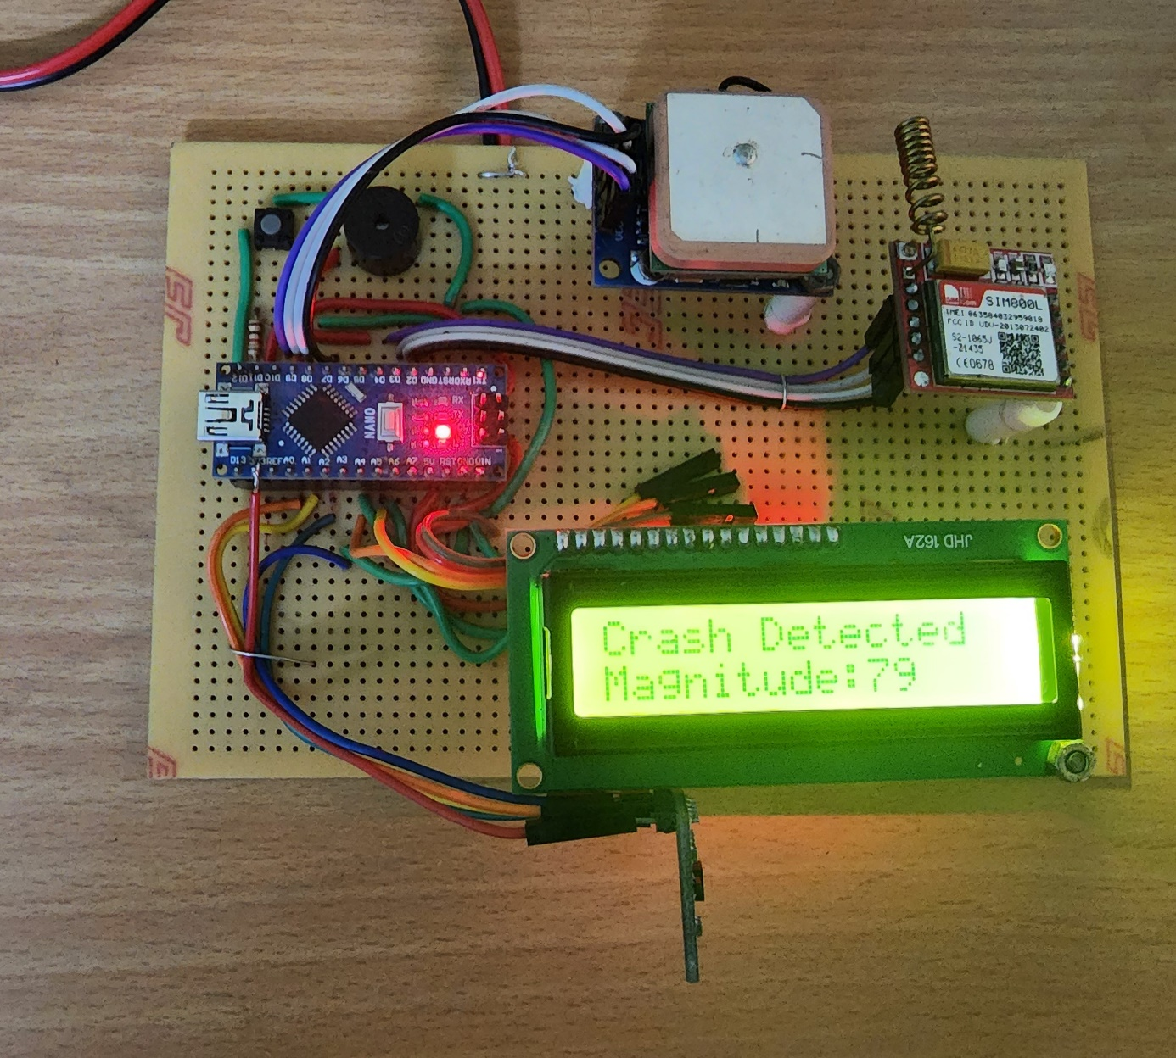
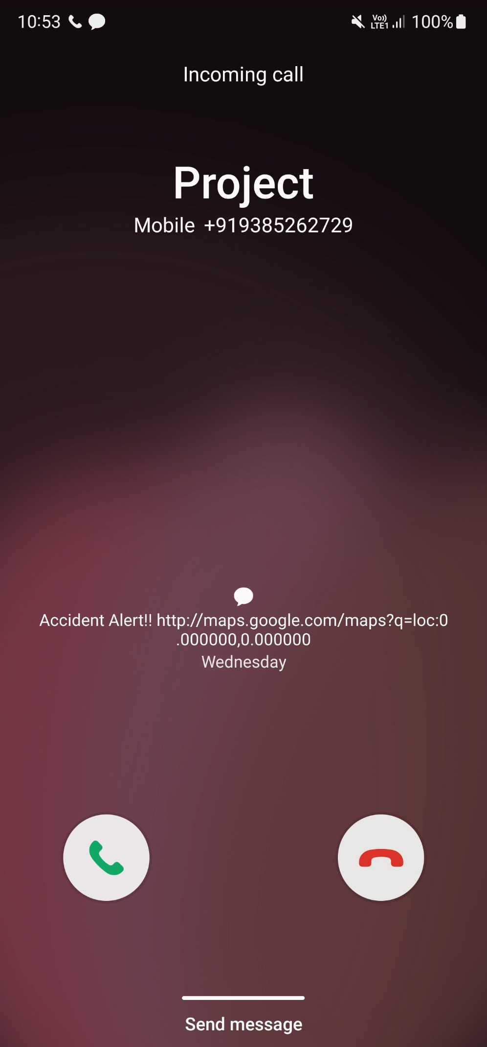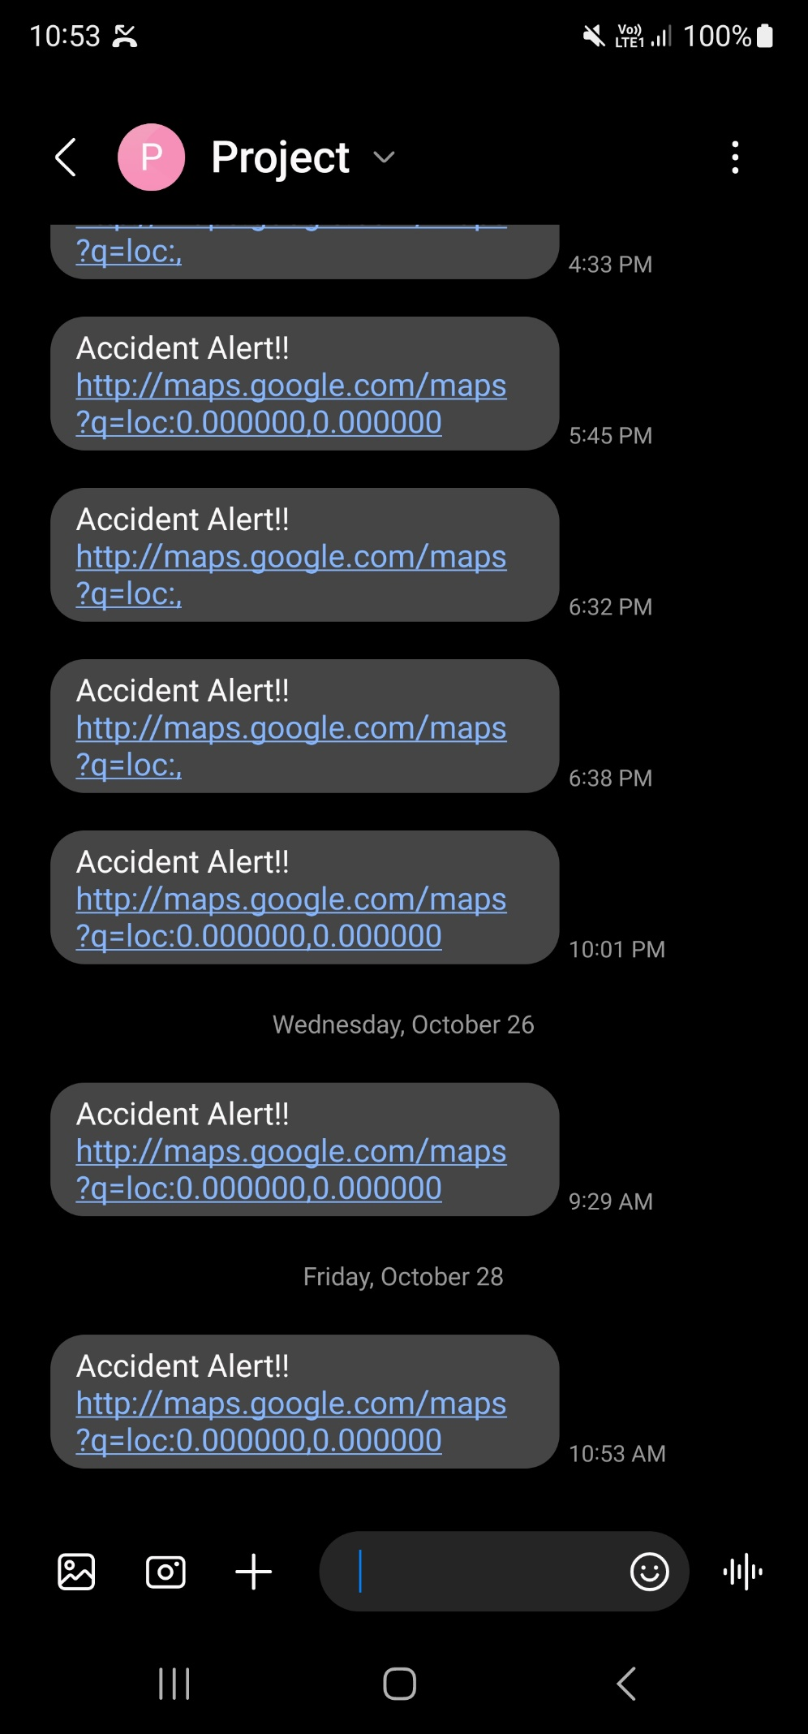

REFERENCE
- Erat, M., Karaman, O. S., &Karamavus, Y. (2018). Analysis of driving characteristics and crash detection. 2018 26th Signal Processing and Communications Applications Conference (SIU). doi:10.1109/siu.2018.8404219
- Kim, T., &Jeong, H.-Y. (2014). A Novel Algorithm for Crash Detection Under General Road Scenes Using Crash Probabilities and an Interactive Multiple Model Particle Filter. IEEE Transactions on Intelligent Transportation Systems, 15(6), 2480–2490. doi:10.1109/tits.2014.2320447
- Tokoro, S., Moriizumi, K., Kawasaki, T., Nagao, T., Abe, K., & Fujita, K. (n.d.). Sensor fusion system for pre-crash safety system. IEEE Intelligent Vehicles Symposium, 2004. doi:10.1109/ivs.2004.1336513
- Singh, G. B., &Haiping Song. (2009). Using Hidden Markov Models in Vehicular Crash Detection. IEEE Transactions on Vehicular Technology, 58(3), 1119–1128. doi:10.1109/tvt.2008.928904
- Sherony, R., & Zhang, C. (2015). Pedestrian and Bicyclist Crash Scenarios in the U.S. 2015 IEEE 18th International Conference on Intelligent Transportation Systems. doi:10.1109/itsc.2015.250
- Scanlon, J. M., Sherony, R., & Gabler, H. C. (2016). Preliminary potential crash prevention estimates for an Intersection Advanced Driver Assistance System in straight crossing path crashes. 2016 IEEE Intelligent Vehicles Symposium (IV). doi:10.1109/ivs.2016.7535532
- Murali, S., & Shankar, R. (2008). Performance Analysis of a Vehicle Crash Control System using Image. 4th IEEE International Symposium on Electronic Design, Test and Applications (delta 2008). doi:10.1109/delta.2008.97
- Sharma, H., Reddy, R. K., & Karthik, A. (2016). S-CarCrash: Real-time crash detection analysis and emergency alert using smartphone. 2016 International Conference on Connected Vehicles and Expo (ICCVE). doi:10.1109/iccve.2016.7
- Zeng, Q., Wu, C., Peng, L., & Li, H. (2015). Novel vehicle crash risk detection based on vehicular sensory system. 2015 IEEE Advanced Information Technology, Electronic and Automation Control Conference (IAEAC). doi:10.1109/iaeac.2015.7428628
- Chan, C.-Y. (2007). Trends in Crash Detection and Occupant Restraint Technology. Proceedings of the IEEE, 95(2), 388–396. doi:10.1109/jproc.2006.888391

